 THE BEE LINE 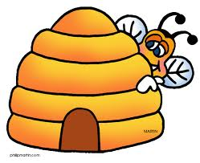
Newsletter of The Mid North Coast Amateur Beekeeping Association
President : Marcus Lewis ph 6656 2287 Secretary : Peter Dickson-Smith
Treasurer: Mal Banks Ph : 02 6649 2009
Ph: 02 6649 0990 Public Officer : Marcus Lewis
Newsletter : Mal Banks Ph : 02 6569 5561
Vice Presidents : Allan Thomas, Paul Campbell Librarian: Fay Karabaic
Keith Harris

November 2015

Last Meeting
The last meeting was held at the Bonville Station Farm, at Bonville on Sunday 8th November. The farm is part of the Bonville Christian Community School and was hosted by Graham Worthy, Paul Campbell and Steve Jawerth.
It was a great location, unfortunately the rain did not let up and the meeting which was well attended, was unable to include a hive inspection.
We will be having another meeting at this location in March.
After much talking and coffee the BBQ was fired up and we all had another great lunch.
Thanks to everybody for attending, and bringing food and raffle items. The rain did ease just enough (to make it possible, with the rain on the tin roof) to hold our regular meeting and our AGM.
The hosts were thanked, apologies were read, and best wishes were sent to Peter who was in hospital at the time.
I read the treasurers’ report, and club business was then discussed. This included educational expenditure, advertising in the press under local community notices, equipment supplies, and the location of future meetings.
Marcus stood down as President and Al Williams chaired the meeting for the election of our committee. After Marcus was re-elected he resumed his position as chair and the committee positions were all filled.
Everything stays the same with the only change being our Vice-presidents. –Now Al Thomas, Paul Campbell, and Keith Harris.
I read out the activities of the club over the last financial year.
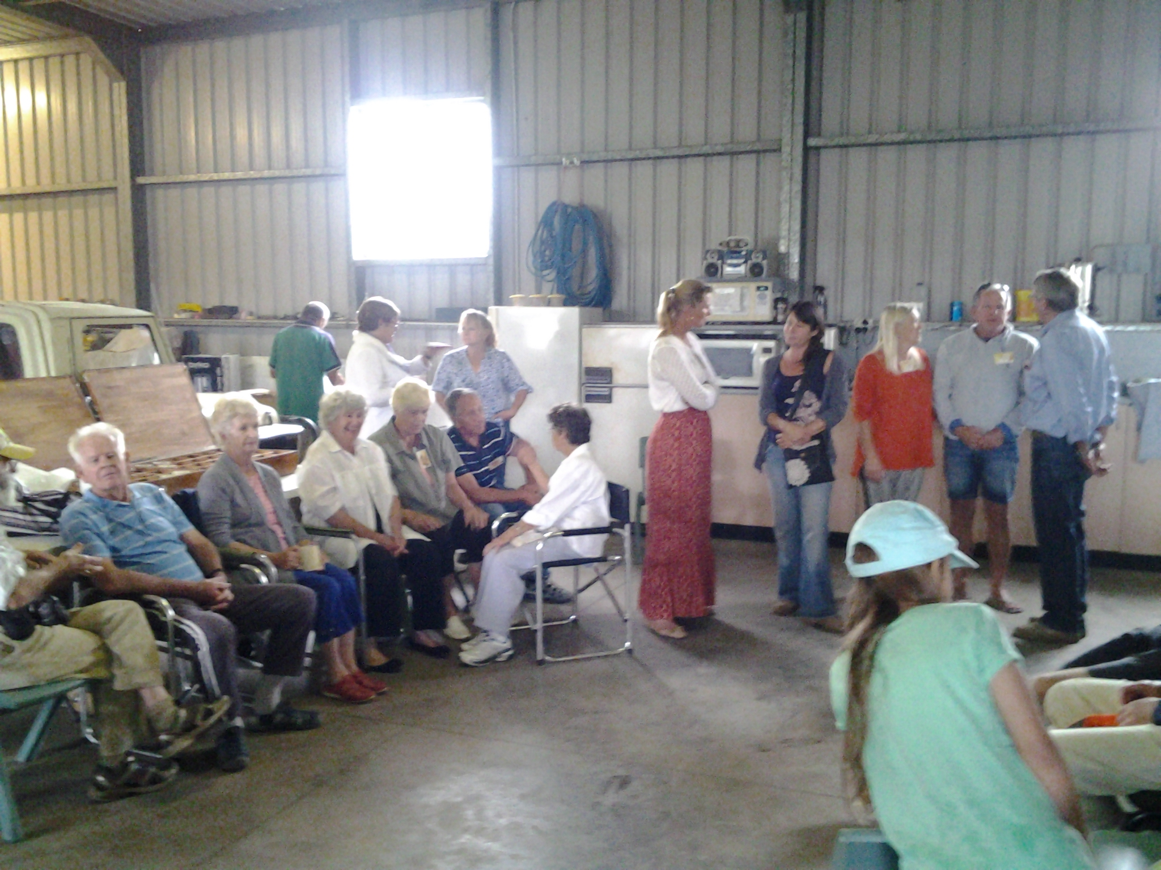
In the big shed at CHCCS
Membership fees and Insurance for 2015 were taken, and I’ll be collecting subs at the next meeting, which will be our Xmas party. The ‘early bird’ fee of $45 applies before Dec 20th. If you’re not planning on attending the next meeting, and wish to pay to take advantage of the early bird rate, contact me at 66490990 to arrange payment.
3 new members joined on the day, so welcome to the club, Geoff, Peter and Iven.
The price of wax keeps going up, so I have purchased a box of foundation sheets for sale to club members at the next meeting, along with more Apithor traps.
Library
Fay and Frank continue to do a great job with managing our ever-growing library.
Please take advantage of our library and return borrowed items at a reasonable time,(generally 1 month).
I have purchased 2 new books(2015 publication dates)) for the club, which will be available in the new year.
1) The Beekeeper’s Problem Solver – james E. Tew
2) The Australian Beekeeping Manual – Robert Owen

FRANK’S HIVE HINTS No 10
Welcome to new beekeepers in our group.
Opening a hive.
Select a sunny day. 10am is ideal as many older bees will be out foraging.
Dress in you protective outfit.
Light smoker and make sure it’s going well.
Smoke yourself –particularly around hands and ankles.
Approach hive quietly from back or side.
Puff smoke 3 times into entrance. Lift lid slightly and puff smoke under. Remove lid and smoke again. Work slowly and carefully. Don’t bump.
Bees don’t like petrol, after-shave or perfumed soap.
Basic equipment.
Hat with veil securely fastened. Long-sleeved shirt, shoes, trousers tucked into socks, or special bee suit and gloves if needed.
Smoker, lighter and fuel. Dry pine needles are best as they produce cool smoke but they build up residue on the smoker. Paperbark, other bark or hessian can be used but these produce more heat and sparks so don’ puff too close to the bees.
Hive tool.
Others: beetle trap, brush, water spray, closed container for bits of wax.
If you keep all your gear together you won’ have to run back to the vehicle or shed to get something while the hive is open.
LOVE THOSE BEES

Sheltering from the rain

Beekeeper’s Problem No 18
The queen excluder is disrupting colony function
Cause: Many beekeeper’s believe that queen excluders restrict free worker bee movement into the supers, thereby causing honey to be stored just beneath the excluder or, alternatively, no honey to be stored at all.
Solution: Interestingly, this bee management problem is not viewed as a troublesome issue by all beekeepers. The basic function of the queen excluder is to restrict the movement of the queen into honey supers. The grid, having openings of 4mm, are made of metal or plastic. This grid allows workers to pass but restricts queens and drones from moving into honey supers. This measurement is critical, requiring excluders to be handled carefully; if there is any damage, the queen will find the resulting opening and move through.
The argument against using queen excluders is that nectar-loaded bees are reluctant to squeeze through the narrow openings and that the grid causes undue restrictions on the colony. This concern will seemingly not be resolved in the near future. There are both supporters and detractors. When there are many colonies to manipulate, a beekeeper will probably use them, while beekeepers with fewer colonies can spend the time to be certain that the queen is not with brood in a honey super that is removed for extracting. There are different styles of excluder, with pricing based on quality of manufacture.
It comes down to a personal choice. If excluders don’t fit in with your colony management philosophy, don’t use them. But bear in mind that you’ll have to deal with the occasional spot of brood in honey supers. The true risk of not using an excluder is that the queen is unintentionally removed from the hive along with a honey super.
Excerpt from ‘The Beekeeper’s Problem Solver.’
Science report
1) Fungus Fouls Bee Semen
A widespread fungus (Nosema apis) that causes dysentery in honey bees can be transmitted from sick male bees to virgin queens.
Prof Baer of The University of Western Australia said the discovery, published in Scientific Reports, had major consequences for breeding programs.
“To this point, semen used for artificial insemination has typically been regarded as safe, and has freely been shipped around the world,” he said. “This finding questions this practice. It calls for additional tests on the semen to avoid spreading the disease across Australia and internationally.”
The researchers found that it takes 3 weeks until the sperm quality of sick males is affected, and they start dying from the disease. Baer says this “gives them time to fly from the hive and mate, transmitting the fungus to virgin queens who, once impregnated, transport it home to their own hives with potentially catastrophic results.”
The scientists glued radio frequency tags onto the back of honey bee workers, revealing that sick bees are less likely to leave the hive to forage and carry less pollen when coming back.
Ed- Australian Science – October
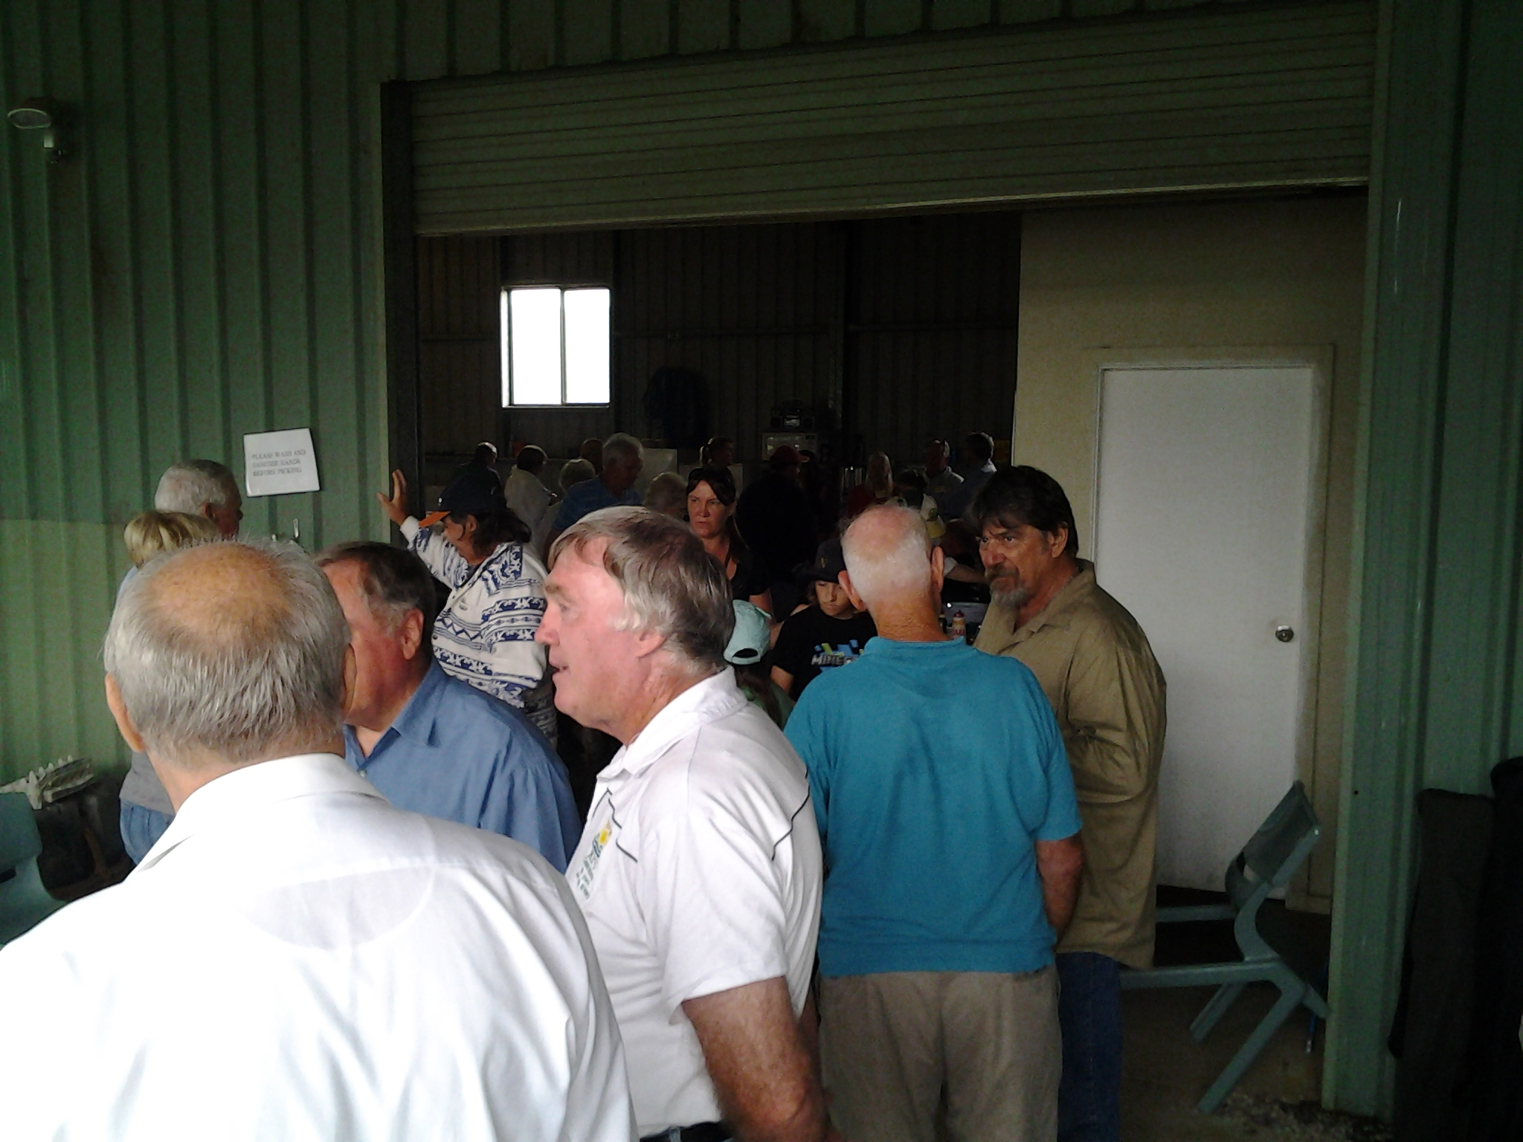
Much discussion at the CHCCS
2) Bees put to Work lugging Pesticides to Flowers
They’re not called worker bees for nothing. Bumblebees buzz from plant to plant collecting food, and plans are afoot to give them another task while they do it – carrying pesticides to where they are needed. Bee Vectoring Technologies in Canada has opened a commercial production plant this month in the hope that the tactic will lure farmers away from indiscriminate crop spraying.
The idea involves placing a tray of organic pesticide powder inside a commercially bred hive. The powder contains a substance to help it stick to bee’s legs and a strain of Clonostachys rosea fungus that is harmless to these insects but attacks crop diseases and pests. “It’s a perfectly natural fungus found very commonly throughout the world,” says Michael Collinson, CEO of BVT.
The bumblebees walk through the powder as they leave the hive. When they land on flowers to gather nectar and pollen, they leave a dusting of pesticide to protect the plant and future fruit. Many crops can be protected this way including blueberries and bell peppers.
“The idea of using bees to carry pesticides isn’t new, but BVT is one of the first to attempt to commercialise the approach.
Honeybees and bumblebees differ in their responses to pesticides in ways that can be hard to predict,” says Dave Goulson at the University of Sussex at Brighton, UK. “What’s more, the EPA generally tests only to see if chemicals are acutely toxic, rather than looking at the effects of long-term exposure.
Collinson says the company is ‘very cautious’ about the insect’s well-being.”Our business is bees. We need these guys to fly for us.”
Ed – Newscientist.com/news

Recipe
Honey-Braised Vegetables with Bean Curd
Ingredients:
8 dried Chinese mushrooms
20 dried lily buds (optional)
2 tablespoons peanut oil
3 thin slices ginger
250g white sweet potato, halved and sliced
2 tablespoons soy sauce
1 tablespoon honey
2 teaspoons sesame oil
45g fried bean curd, cut into 1 cm strips
2 teaspoons cornflour
4 spring onions cut into 4cm lengths
1 x 410 g can baby corn
1 x 230g canned water chestnuts, drained
Method:
Soak mushrooms in hot water to cover for 30 mins
1)Drain, reserving ¾ cup liquid. Squeeze mushrooms
to remove excess liquid. Remove stems. Slice mushrooms thinly.
Slice ginger thinly.
2)Soak the lily buds separately, in warm water for 30 mins, drain
3)Heat the oil in a wok or heavy-based frypan, swirling gently to coat base and side
Add ginger and stir fry over medium heat for 1 minute
Add the mushrooms and lily buds and stir fry for 30 seconds
Add sweet potato with soy, honey, sesame oil, mushroom liquid
and fried bean curd. Simmer, uncovered, 15 mins
4) Dissolve cornflour in a little water, add to pan
Stir until liquid thickens. Add the spring onions, corn and water chestnuts.
Simmer 1 minute.

Next Meeting

MNCABA Xmas Party

This will be held on Sunday, 13th December at Erwin & Brigitte Grote’s house at Newee Creek.

Please be there at 10:00am for a 10:30 start.

Please bring protective clothing, for a hive inspection.

Lunch will be at 12:30 pm – Cost $5

Address - 28 Grotes Road Newee Creek NSW
Phone 6568 1731

No raffle – bring child toy for donation

Directions:
From the North - Turn left from the Pacific Hwy at the Link Rd turnoff to Nambucca Heads
Turn Right onto Old Coast Road, then right again onto Wirrimbi Rd.
Turn right again at Newee Creek Road
Again turn right onto Soldier Settlers Rd and then turn right into the third driveway and follow to Brigitte and Erwin’s house. (look for blue plastic letterbox).
From the South - From the Highway just across the river north of Macksville, turn left onto Ferry Rd, which turns into Rodeo Drive, then turn right into Wirrimbi Rd and left into Newee Creek Rd and follow the directions above to the house.
Any questions call :
Mal Banks - 6649 099 Or Peter Dickson-Smith - 6649 2009

